

**MATHEMATICS  
Applications Units 3 & 4**

**Test 3 – Graphs**

**Chapter 5**

**Semester 1 2017**

# 

**Section One – Calculator Free**

Time allowed for this section

Working time for this section: 30 minutes

Marks available: 34 marks

## Material required/recommended for this section

##### To be provided by the supervisor

This Question/Answer booklet

Formula sheet

##### To be provided by the candidate

Standard items: pens, pencils, pencil sharpener, eraser, correction fluid, ruler, highlighters

Special items: Nil

## Important note to candidates

No other items may be used in this section of the examination. It is **your** responsibility to ensure that you do not have any unauthorised notes or other items of a non-personal nature in the examination room. If you have any unauthorised material with you, hand it to the supervisor **before** reading any further.

1. (4 marks)  
   A teacher drives home from school every day. The following diagram shows all possible routes home and the time taken in minutes to travel each route.



Use the diagram above to find:

1. the shortest route and time taken for the teacher to drive home.

(Use colour to show this route) [2]

1. the shortest time taken for the teacher to drive home, if she must stop at the shops on the way home. [2]
2. (5 marks)  
   Consider the table below showing the length of cable required to connect computer terminals A, B, C and D to each other and to the main terminal M.

(all measurements are in metres).

|  |  |  |  |  |  |
| --- | --- | --- | --- | --- | --- |
|  | **A** | **B** | **C** | **D** | **M** |
| **A** | - | 4 | 7 | 3 | 2 |
| **B** | 4 | - | 3 | - | 5 |
| **C** | 7 | 3 | - | 5 | 6 |
| **D** | 3 | - | 5 | - | 5 |
| **M** | 2 | 5 | 6 | 5 | - |

1. Draw a possible network [2]
2. Draw the minimum spanning tree. Mark it on your network in colour. [2]
3. What is the minimum amount of cable needed? [1]
4. [1 mark]  
   A connected planar graph has 12 edges. This graph could have:   
   (select one of the answers)
5. 5 vertices and 6 faces
6. 5 vertices and 8 faces
7. 6 vertices and 8 faces
8. 6 vertices and 9 faces
9. 7 vertices and 9 faces
10. [1 mark]   
    Find the sum of degrees in the following graph:

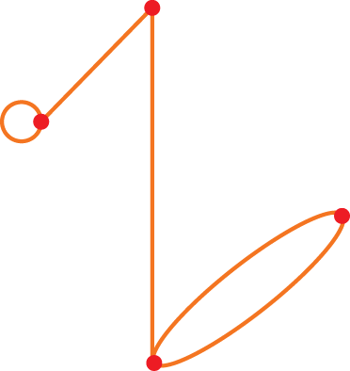

1. [2 marks]   
   Write the adjacency matrices to represent the graph below?

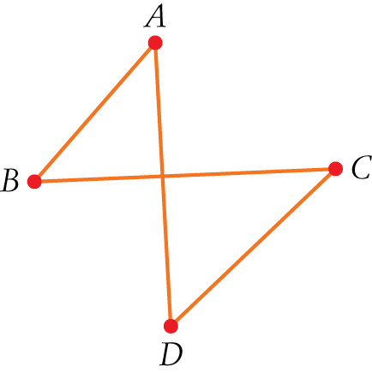

1. [1 mark]   
   Which one of the following graphs is Eulerian? (select one)

A 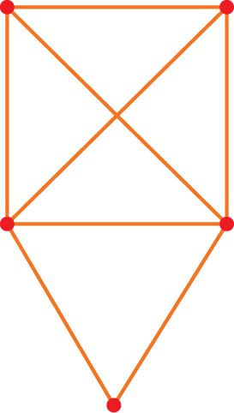 B 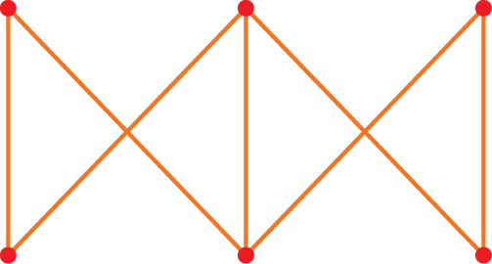 C 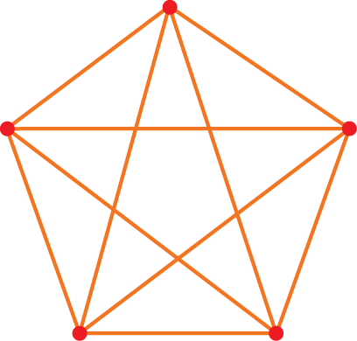

D  E 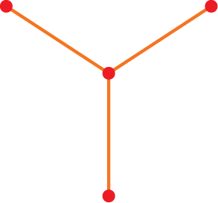

1. [1 mark]

A salesman is selling educational software to a number of different schools. He will visit every school once only and return to the school at which he started.

This situation can best be represented by: (select one)

1. A Hamiltonian cycle
2. A semi-Eulerian graph
3. A Hamiltonian path
4. A Eulerian graph
5. A minimum spanning tree
6. [2 marks]

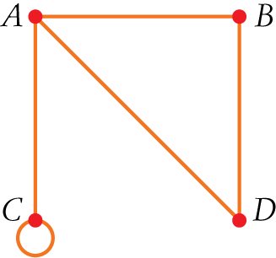

The following matrix represents the graph above. The matrix is missing two values k and m. State the values of k and m.



k = m =

1. [2 marks]   
   Redraw this graph as a planar graph:

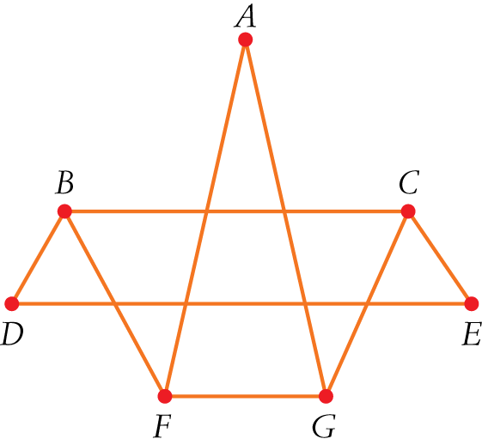

1. [5 marks]   
   Two tennis teams are playing each other in a grand final. Each team has four players and each player on the team plays each player on the other team once. Unfortunately, one player from one team received an injury and could not play.
2. Represent the games played using a bipartite graph with the eight players as the vertices of the graph and the edges the games played.
3. How many games were played?

1. [1 mark]   
   Which edge/s need to be added or removed to make the following graph semi-Eulerian?

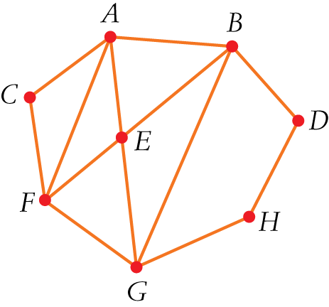

1. [4 marks]

For the above matrix:

1. What do all the zeros in row B indicate?
2. What does the ‘1’ at the intersection of row A column A indicate?
3. What does the ‘2’ in the matrix represent?
4. Draw the graph that corresponds to this matrix.

1. [5 marks]  
   For the following graph:

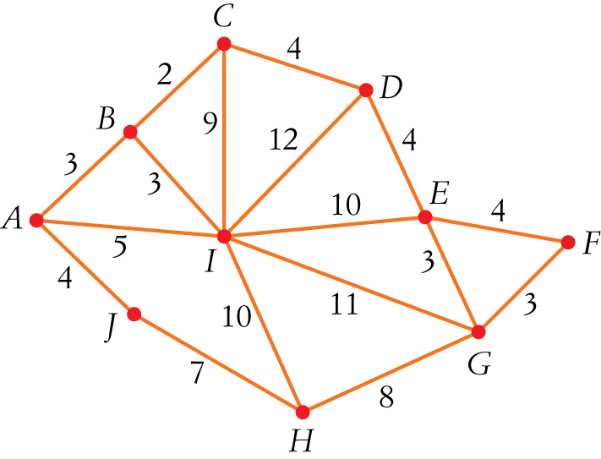

1. Use Prim’s algorithm to find the minimum spanning tree.
2. What is the total weight of this minimum spanning tree?

**End of Section One**